**EBS VOLUME TYPES**

Before discussing about the volume types we need to discuss the following terms which will play an important role in terms of volume type decide:

**1.IOPS:**Iops is the standard unit of measurement for the maximum number of read and writes a drive can carry out every second.

**2.Throughput:**throughput is the volume of data that was transferred from a source at any given time.Bandwidth is the measure of how much data could theoretically be transferred froma source at any given time.

Think of throughput as the cars and bandwidth as the freeway. Throughput can easily be bottlenecked by bandwidth. This deal primarily with the networking side of the storage system, and how quickly the storage system can transmit the data to the endpoints in a local area network, or a wide area network.

**3.Latency :** Latency s how fast the data packets inside the pipe travel from client to server and back. Relating it back to the previous example, latency is how fast the cars are travelling on the freeway.



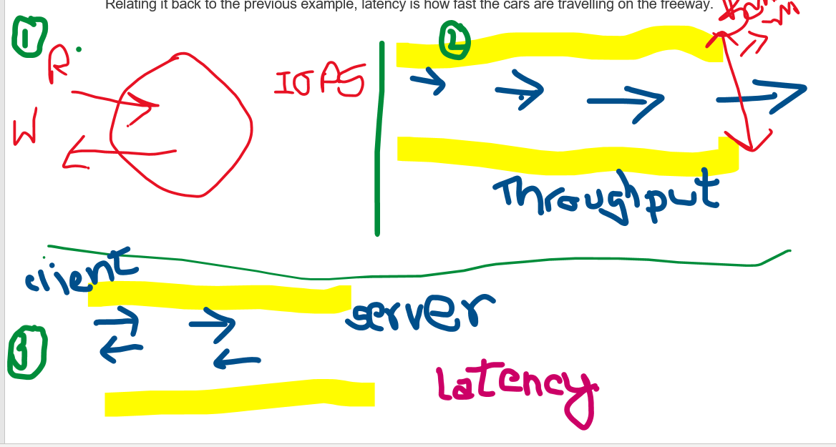

**Ebs volumes**comes in 6 types:

1.gp2/gp3 are ssd types which we use most of the time.

These ebs volumes are categorised on the basis of characteristics such as size of volume,the throughput of the volume and the IOPS

Note:only gp2/gp3 and io1/io2 can be used as boot volumes means where the root os can be stored.

**GENERAL PURPOSE SSD**

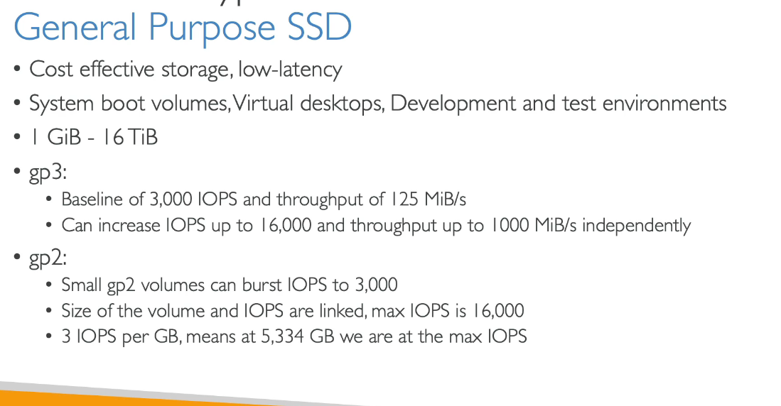

Provisioned iops(piops) ssd

**HDD(HARD DISK DRIVES)**

